Robust clipped correlation: GBPUSD and USDJPY
Method 04 / daily log returns clipped at ±0.01, ±0.02, ±0.03 / Alpari D1 full available history

Study setup
Logical pair: GBPUSD , USDJPY
Broker symbols: GBPUSD_i , USDJPY_i
Snapshot: 2026-11-03_majors_alpari_D1
Timeframe: D1
Matched return window: 1999-01-05 to 2026-11-02 (UTC bar dates)
Matched return count n: 7200
Dropped unfinished last bar dated 2026-11-03 UTC after a tick-volume check against the prior complete day.
Clip bounds c in log-return units: 0.01, 0.02, 0.03 (about ±1%, ±2%, ±3% on the log scale). Headline c = 0.02.
Clipping caps a day's magnitude at ±c and keeps the row; it does not drop the day, so n is the same at every c.
Complete matched rows (Excel): GBPUSD-USDJPY_Clipped_D1.xlsx
Complete matched rows (HTML table): GBPUSD-USDJPY_Clipped_D1_data.html

Method carried forward
Each matched daily log return of close, ln(close_t / close_t-1), is clipped in the broker quote direction before Pearson correlation: x_tilde = min(c, max(-c, x)) and y_tilde = min(c, max(-c, y)), then rho_clip = Pearson(x_tilde, y_tilde) on the same rows as raw Pearson r. Quotes are not inverted. A day beyond ±c stays in the sample at the cap; n does not change. rho_clip is symmetric under swap of the two symbols. rho_clip = 0 means no straight-line link among the clipped values in this sample; it does not mean no link of any kind. The score is not a cause, not a lead, and not a trading signal. Daily rows are not independent draws, so the two-sided p-value and Fisher interval are reported and treated as secondary to rho_clip. Cap-hit counts (|log return| > c) flag how much of each leg was capped.

Raw Pearson on the same rows
Pearson r: -0.198556
Two-sided p-value: 6.38567e-65
Approximate 95% Fisher interval: [-0.220643, -0.176265]
This is the unclipped comparison required by the method. The headline score is rho_clip at c = 0.02 below.

Clipped results
n = 7200 at every c. Headline row is c = 0.02. Cap-hit count is the number of days with |log return| > c before clipping.
c | rho_clip | p | ci_low | ci_high | rho_minus_r | GBPUSD_cap_hits | USDJPY_cap_hits | GBPUSD_cap_share | USDJPY_cap_share
0.01 | -0.262618 | 7.1833378e-114 | -0.28399446 | -0.24098089 | -0.064062626 | 513 | 646 | 0.07125 | 0.089722
0.02 | -0.235694 | 1.8457748e-91 | -0.25739195 | -0.21375885 | -0.037138664 | 39 | 75 | 0.005417 | 0.010417
0.03 | -0.218333 | 1.9500506e-78 | -0.24022087 | -0.19622379 | -0.01977776 | 11 | 17 | 0.001528 | 0.002361

Conclusion
Over 7200 matched daily log-return rows for GBPUSD and USDJPY (broker quote directions unchanged), headline robust clipped correlation at c=0.02 is -0.2357 (negative, weak straight-line association among clipped values in this sample). Approximate 95% Fisher interval on the clipped series: [-0.2574, -0.2138]. Same-sample raw Pearson r is -0.1986 (rho_clip minus r = -0.0371). Sensitivity across the fixed grid: c=0.01 same sign; c=0.02 same sign; c=0.03 same sign. Two-sided p under the usual independent bivariate-normal model is 1.846e-91; that model does not match linked daily FX returns, so treat p as secondary. This does not establish cause, lead-lag, or a lasting trading rule.

What to look at in this file next time
1) rho_clip at c = 0.02 versus raw Pearson r. 2) Whether c = 0.01 and c = 0.03 keep the same sign as 0.02. 3) Cap-hit counts before treating a large gap as settled. 4) The ±0.02 lines on the returns chart and the clip box on the scatter.

Charts
Daily closes

Daily log returns with +/- 0.02 clip lines
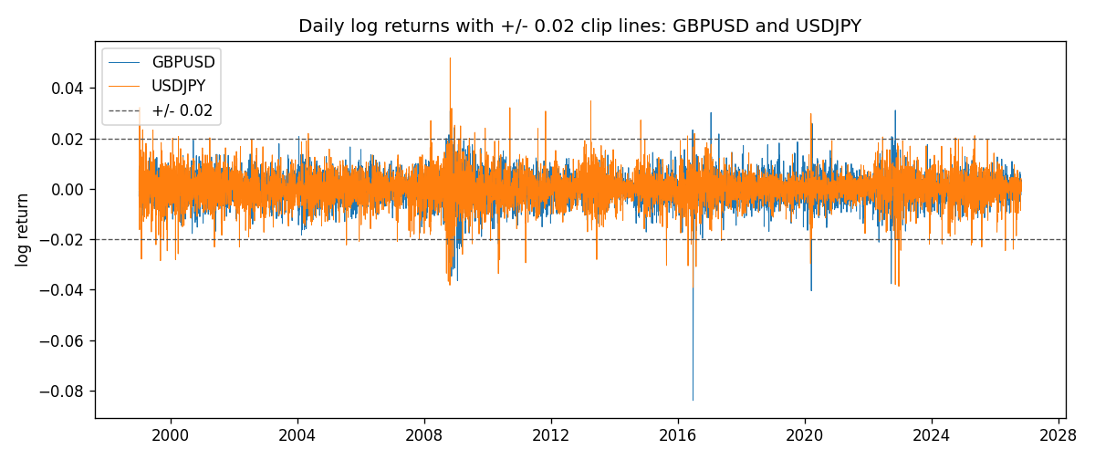
Log-return scatter with +/- 0.02 clip box
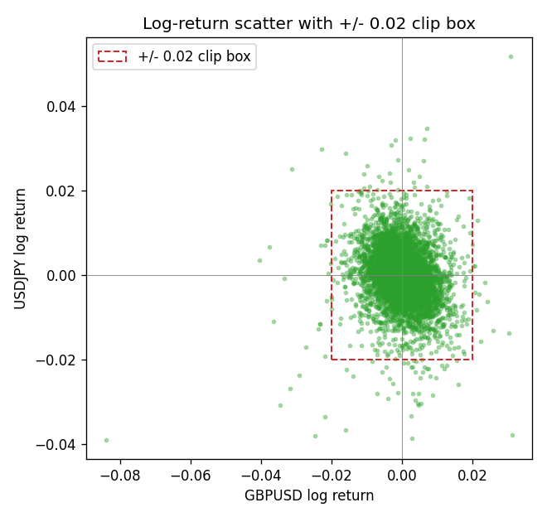

Data report
Every matched row that entered the clipped and raw correlations is stored in the sibling Excel workbook named GBPUSD-USDJPY_Clipped_D1.xlsx. That file is the complete data archive for redrawing charts. Embedding all rows as a Word table is impractical at this length; the Word file holds the column list, column summaries, and the first and last 15 matched rows.
Columns: time, GBPUSD_open, USDJPY_open, GBPUSD_high, USDJPY_high, GBPUSD_low, USDJPY_low, GBPUSD_close, USDJPY_close, GBPUSD_tick_volume, USDJPY_tick_volume, GBPUSD_spread, USDJPY_spread, GBPUSD_real_volume, USDJPY_real_volume, GBPUSD_log_return, USDJPY_log_return, GBPUSD_log_return_clip_0p01, USDJPY_log_return_clip_0p01, GBPUSD_log_return_clip_0p02, USDJPY_log_return_clip_0p02, GBPUSD_log_return_clip_0p03, USDJPY_log_return_clip_0p03
Column summaries (matched calculation rows)
column | count | mean | std | min | 25% | 50% | 75% | max
GBPUSD_open | 7200 | 1.5159933 | 0.21821503 | 1.06854 | 1.3249725 | 1.51133 | 1.63163 | 2.1066
USDJPY_open | 7200 | 113.81122 | 19.205564 | 75.693 | 104.42925 | 110.991 | 120.69125 | 163.824
GBPUSD_high | 7200 | 1.5222906 | 0.21878569 | 1.08366 | 1.329785 | 1.518035 | 1.638315 | 2.1161
USDJPY_high | 7200 | 114.30876 | 19.267108 | 76.001 | 104.8815 | 111.4435 | 121.26 | 163.978
GBPUSD_low | 7200 | 1.5096683 | 0.2174426 | 1.03518 | 1.319445 | 1.50319 | 1.6243 | 2.0983
USDJPY_low | 7200 | 113.28793 | 19.133561 | 75.402 | 103.89 | 110.5305 | 120.17 | 163.628
GBPUSD_close | 7200 | 1.5160611 | 0.21817876 | 1.06879 | 1.3250775 | 1.511235 | 1.63193 | 2.1065
USDJPY_close | 7200 | 113.82409 | 19.220954 | 75.811 | 104.42 | 111.028 | 120.6855 | 163.851
GBPUSD_tick_volume | 7200 | 94838.03 | 153554.65 | 62 | 10001.75 | 52905.5 | 91812.25 | 1273370
USDJPY_tick_volume | 7200 | 106136.9 | 179308.31 | 149 | 9925 | 53095 | 92761 | 1803508
GBPUSD_spread | 7200 | 26.967917 | 19.192953 | 0 | 11 | 20 | 50 | 50
USDJPY_spread | 7200 | 20.325556 | 17.633971 | 0 | 6 | 11 | 30 | 50
GBPUSD_real_volume | 7200 | 3.5565837e+09 | 8.4444068e+10 | 0 | 0 | 0 | 0 | 2.4038164e+12
USDJPY_real_volume | 7200 | 3.470121e+10 | 1.6077679e+11 | 0 | 0 | 0 | 0 | 3.8834203e+12
GBPUSD_log_return | 7200 | -2.396e-05 | 0.00564572 | -0.08388241 | -0.0031301 | 3.232e-05 | 0.00317911 | 0.03112653
USDJPY_log_return | 7200 | 4.769e-05 | 0.00620489 | -0.03908203 | -0.00320192 | 0.00011421 | 0.00340709 | 0.05184024
GBPUSD_log_return_clip_0p01 | 7200 | 1.491e-05 | 0.00484411 | -0.01 | -0.0031301 | 3.232e-05 | 0.00317911 | 0.01
USDJPY_log_return_clip_0p01 | 7200 | 9.079e-05 | 0.00508579 | -0.01 | -0.00320192 | 0.00011421 | 0.00340709 | 0.01
GBPUSD_log_return_clip_0p02 | 7200 | -1.18e-06 | 0.00542936 | -0.02 | -0.0031301 | 3.232e-05 | 0.00317911 | 0.02
USDJPY_log_return_clip_0p02 | 7200 | 6.537e-05 | 0.00593031 | -0.02 | -0.00320192 | 0.00011421 | 0.00340709 | 0.02
GBPUSD_log_return_clip_0p03 | 7200 | -1.183e-05 | 0.00553826 | -0.03 | -0.0031301 | 3.232e-05 | 0.00317911 | 0.03
USDJPY_log_return_clip_0p03 | 7200 | 4.996e-05 | 0.00613841 | -0.03 | -0.00320192 | 0.00011421 | 0.00340709 | 0.03
First 15 matched rows (selected columns)
time | GBPUSD_close | USDJPY_close | GBPUSD_log_return | USDJPY_log_return | GBPUSD_log_return_clip_0p02 | USDJPY_log_return_clip_0p02
1999-01-05 | 1.6547 | 111.92 | -0.0028966287 | -0.00017868311 | -0.0028966287 | -0.00017868311
1999-01-06 | 1.6537 | 112.77 | -0.00060452184 | 0.0075660159 | -0.00060452184 | 0.0075660159
1999-01-07 | 1.6502 | 111.33 | -0.002118709 | -0.012851583 | -0.002118709 | -0.012851583
1999-01-08 | 1.6405 | 110.8 | -0.0058954193 | -0.0047719894 | -0.0058954193 | -0.0047719894
1999-01-11 | 1.6312 | 109.02 | -0.0056851331 | -0.016195423 | -0.0056851331 | -0.016195423
1999-01-12 | 1.6349 | 112.6 | 0.0022657001 | 0.032310364 | 0.0022657001 | 0.02
1999-01-13 | 1.6499 | 113.52 | 0.0091330396 | 0.0081373171 | 0.0091330396 | 0.0081373171
1999-01-14 | 1.6531 | 113.52 | 0.0019376331 | 0 | 0.0019376331 | 0
1999-01-15 | 1.6502 | 114.15 | -0.0017558204 | 0.0055343401 | -0.0017558204 | 0.0055343401
1999-01-18 | 1.6522 | 114.16 | 0.0012112405 | 8.7600193e-05 | 0.0012112405 | 8.7600193e-05
1999-01-19 | 1.6553 | 113.52 | 0.0018745281 | -0.0056219403 | 0.0018745281 | -0.0056219403
1999-01-20 | 1.6472 | 112.91 | -0.0049053846 | -0.0053879917 | -0.0049053846 | -0.0053879917
1999-01-21 | 1.6524 | 113.87 | 0.0031518998 | 0.0084664056 | 0.0031518998 | 0.0084664056
1999-01-22 | 1.6565 | 114.56 | 0.0024781662 | 0.0060412564 | 0.0024781662 | 0.0060412564
1999-01-25 | 1.6585 | 113.72 | 0.0012066366 | -0.0073594164 | 0.0012066366 | -0.0073594164
Last 15 matched rows (selected columns)
time | GBPUSD_close | USDJPY_close | GBPUSD_log_return | USDJPY_log_return | GBPUSD_log_return_clip_0p02 | USDJPY_log_return_clip_0p02
2026-10-13 | 1.32534 | 158.305 | 0.0036434319 | -0.0018932826 | 0.0036434319 | -0.0018932826
2026-10-14 | 1.31884 | 158.317 | -0.0049164679 | 7.5800166e-05 | -0.0049164679 | 7.5800166e-05
2026-10-15 | 1.32757 | 158.024 | 0.0065976411 | -0.0018524319 | 0.0065976411 | -0.0018524319
2026-10-16 | 1.33257 | 157.964 | 0.0037592051 | -0.00037976126 | 0.0037592051 | -0.00037976126
2026-10-19 | 1.33024 | 158.517 | -0.0017500314 | 0.0034946841 | -0.0017500314 | 0.0034946841
2026-10-20 | 1.3377 | 158.16 | 0.0055923442 | -0.0022546642 | 0.0055923442 | -0.0022546642
2026-10-21 | 1.33937 | 158.108 | 0.0012476328 | -0.00032883504 | 0.0012476328 | -0.00032883504
2026-10-22 | 1.33967 | 156.755 | 0.00022396082 | -0.0085942669 | 0.00022396082 | -0.0085942669
2026-10-23 | 1.33684 | 156.81 | -0.0021146949 | 0.00035080446 | -0.0021146949 | 0.00035080446
2026-10-26 | 1.33359 | 157.458 | -0.0024340661 | 0.0041238746 | -0.0024340661 | 0.0041238746
2026-10-27 | 1.33044 | 157.894 | -0.0023648393 | 0.0027651658 | -0.0023648393 | 0.0027651658
2026-10-28 | 1.33254 | 157.743 | 0.0015771808 | -0.00095679538 | 0.0015771808 | -0.00095679538
2026-10-29 | 1.33733 | 157.683 | 0.0035881935 | -0.00038043789 | 0.0035881935 | -0.00038043789
2026-10-30 | 1.33913 | 157.516 | 0.0013450605 | -0.0010596481 | 0.0013450605 | -0.0010596481
2026-11-02 | 1.3406 | 157.933 | 0.0010971256 | 0.0026438521 | 0.0010971256 | 0.0026438521

